**BDM 1034 - Application Design for Big Data**

**Lab3**

**Submitted by: Aadarsha Chapagain**

**Student ID:C0825975**

**Submitted to: Prof. Teresa Zhu**

Here I have attached the certificate I achieved from Linkedin learning for Course “**Microsoft SQL Server 2019 Essential Training”** along with the Screenshot of score I achieved

**Chapter 1:**

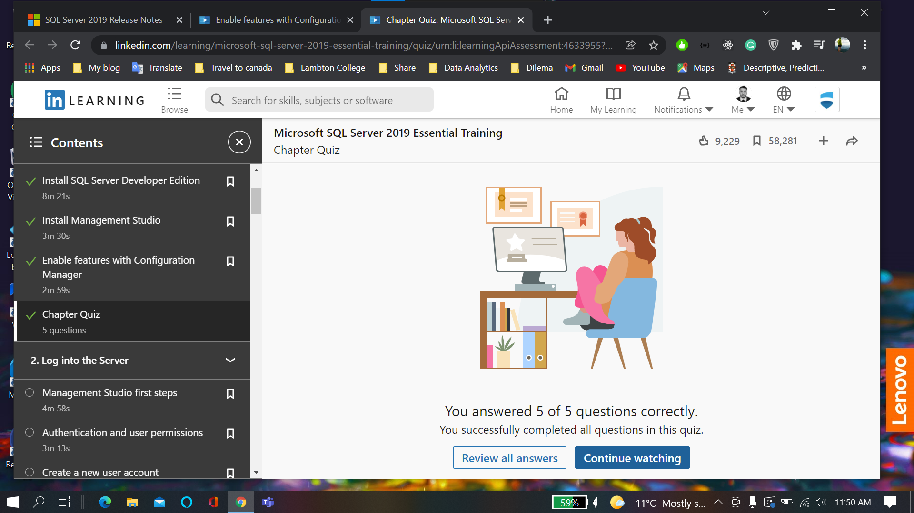

Chapter 2: **Login with different user**

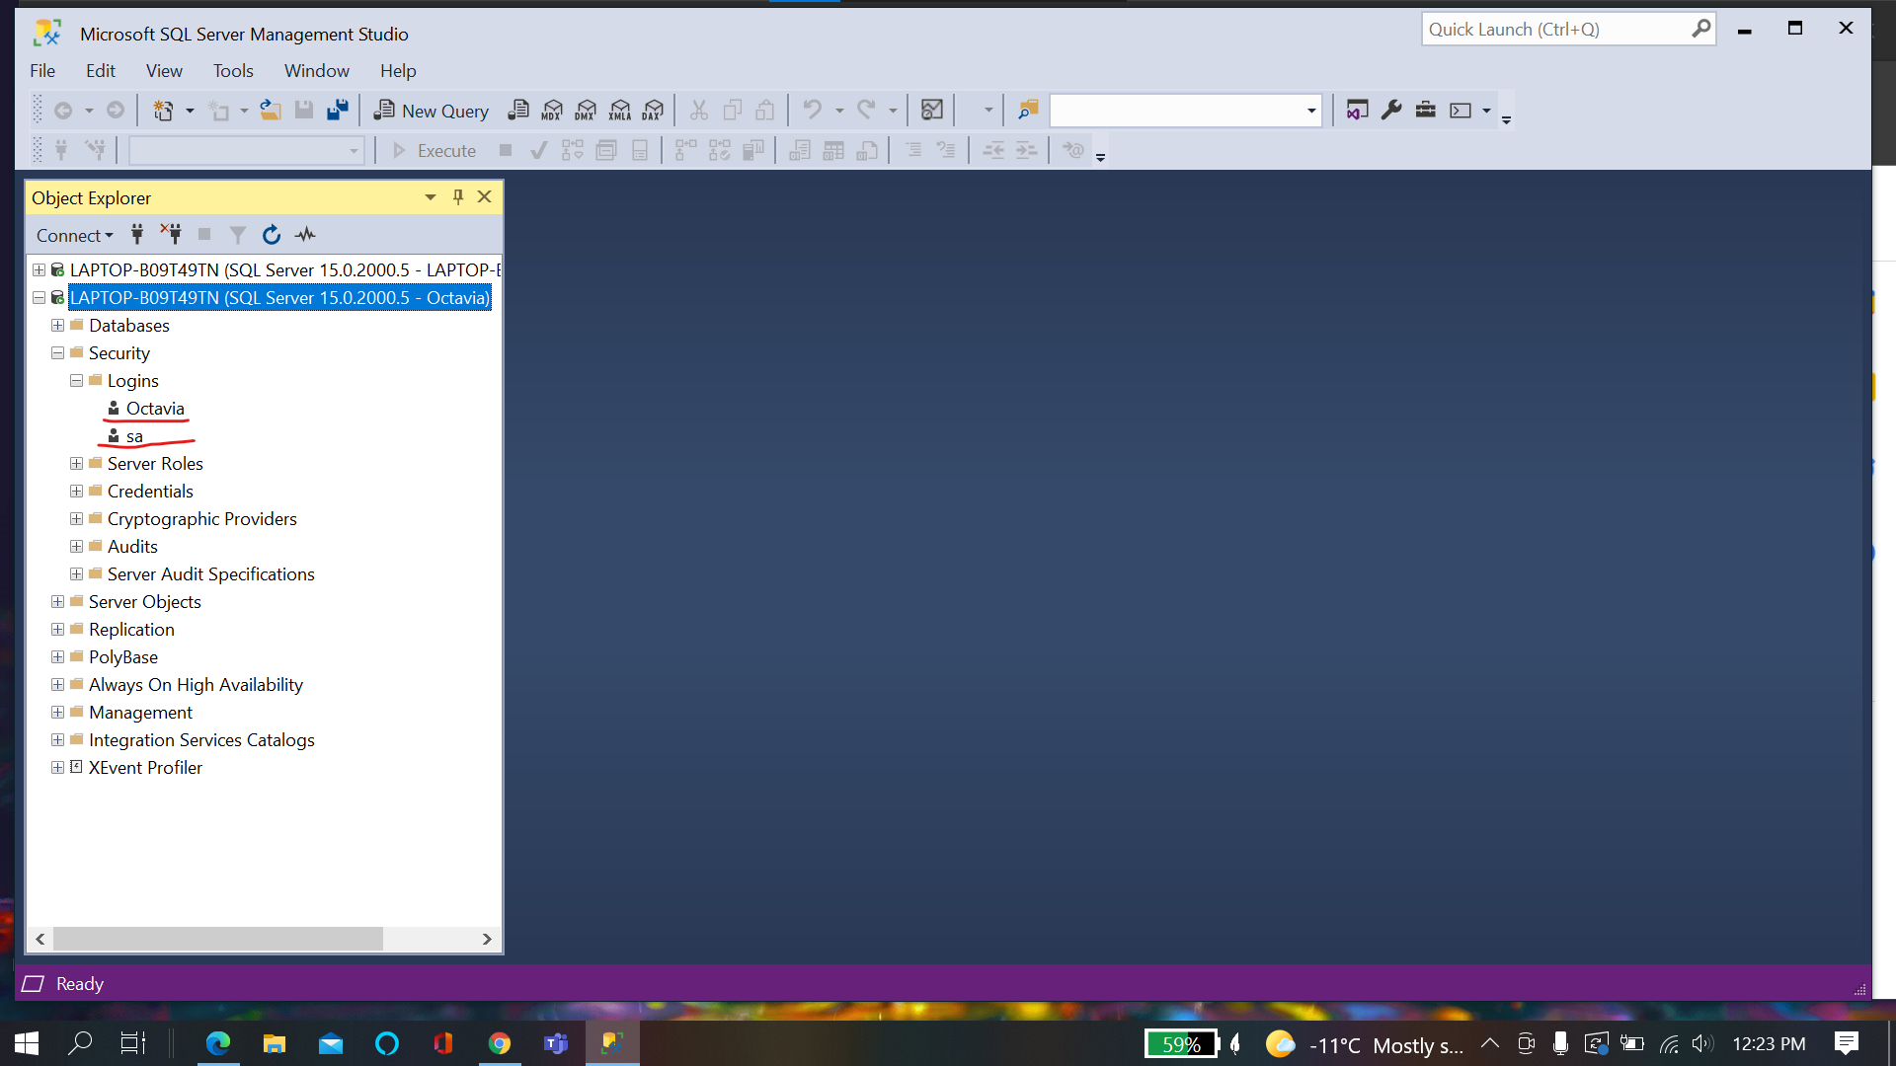

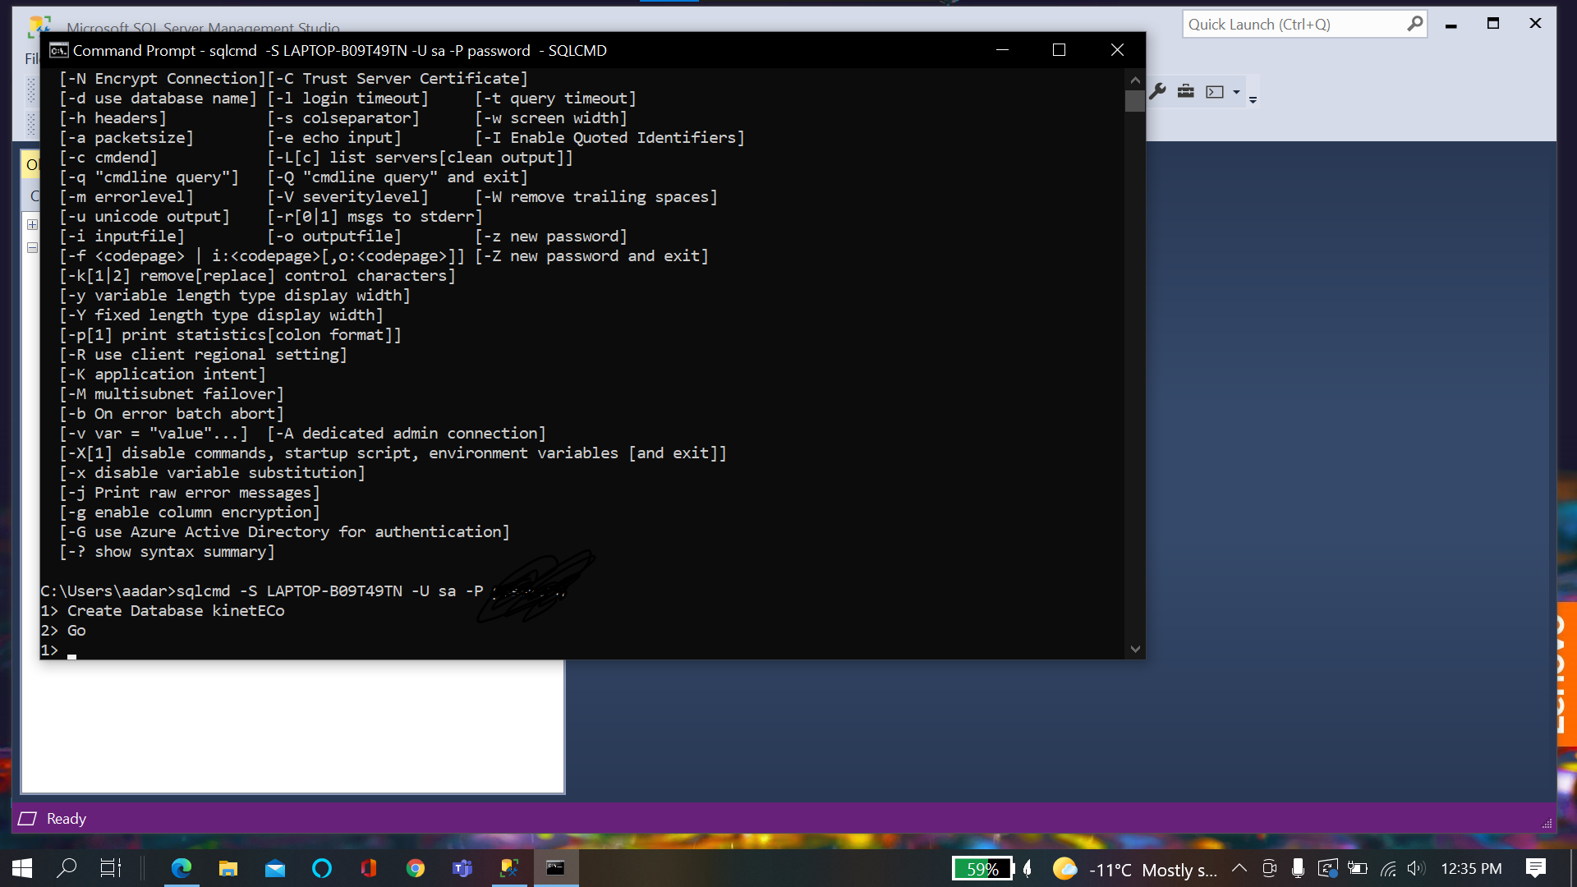

**Chapter Quiz:**

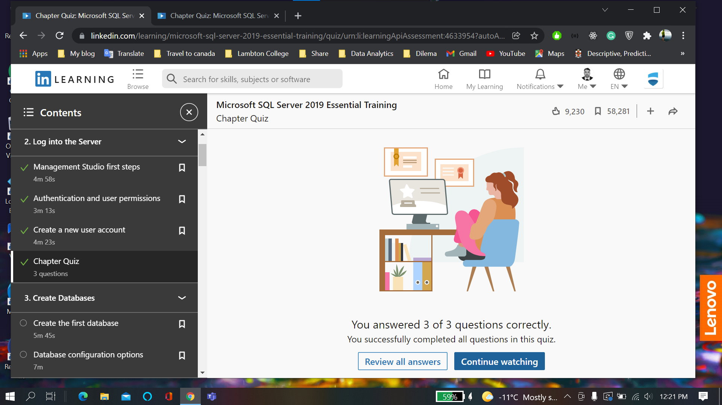

**Chapter 3: Create Databases**

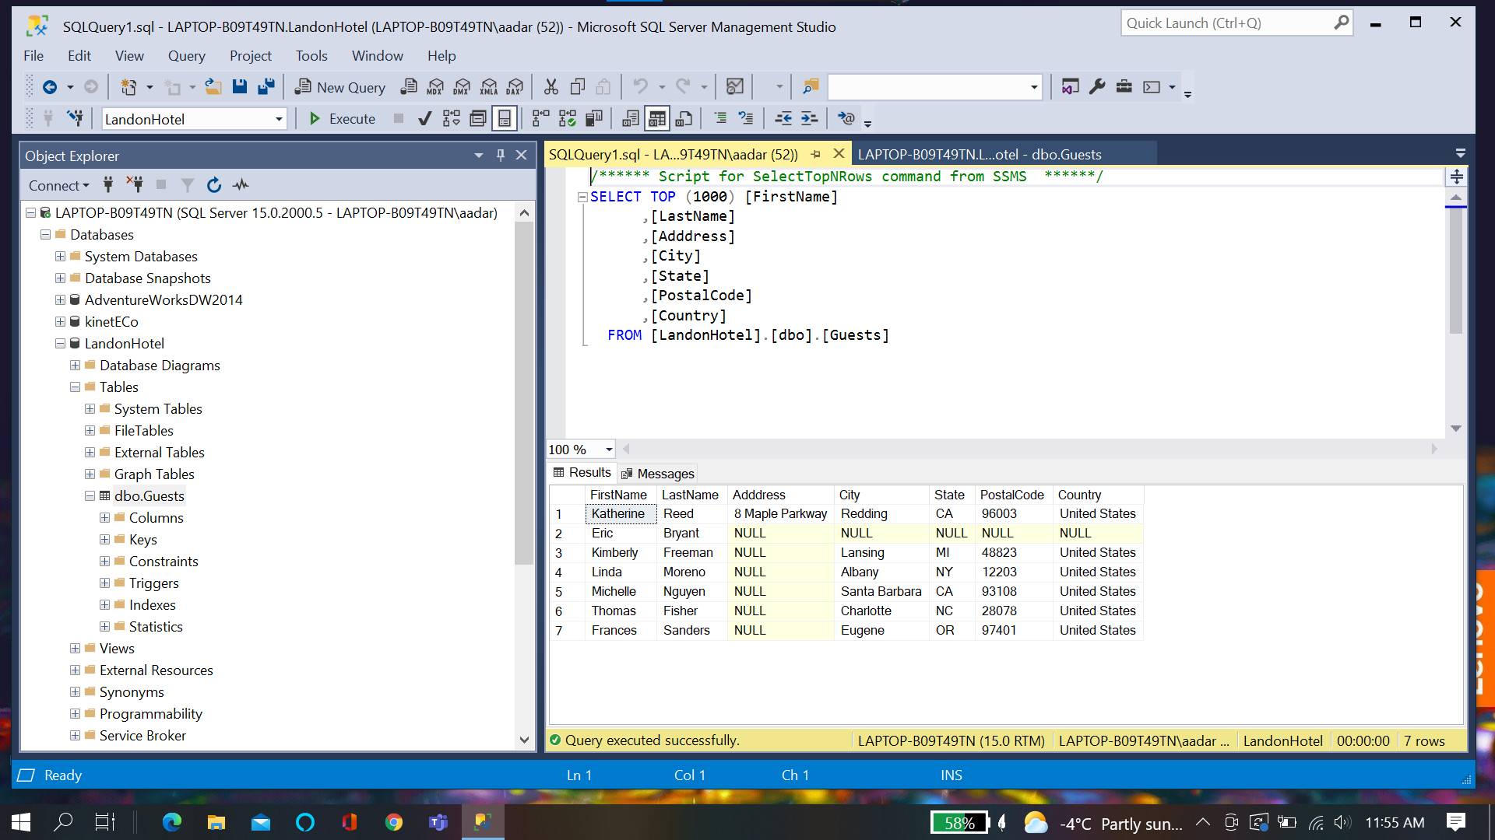

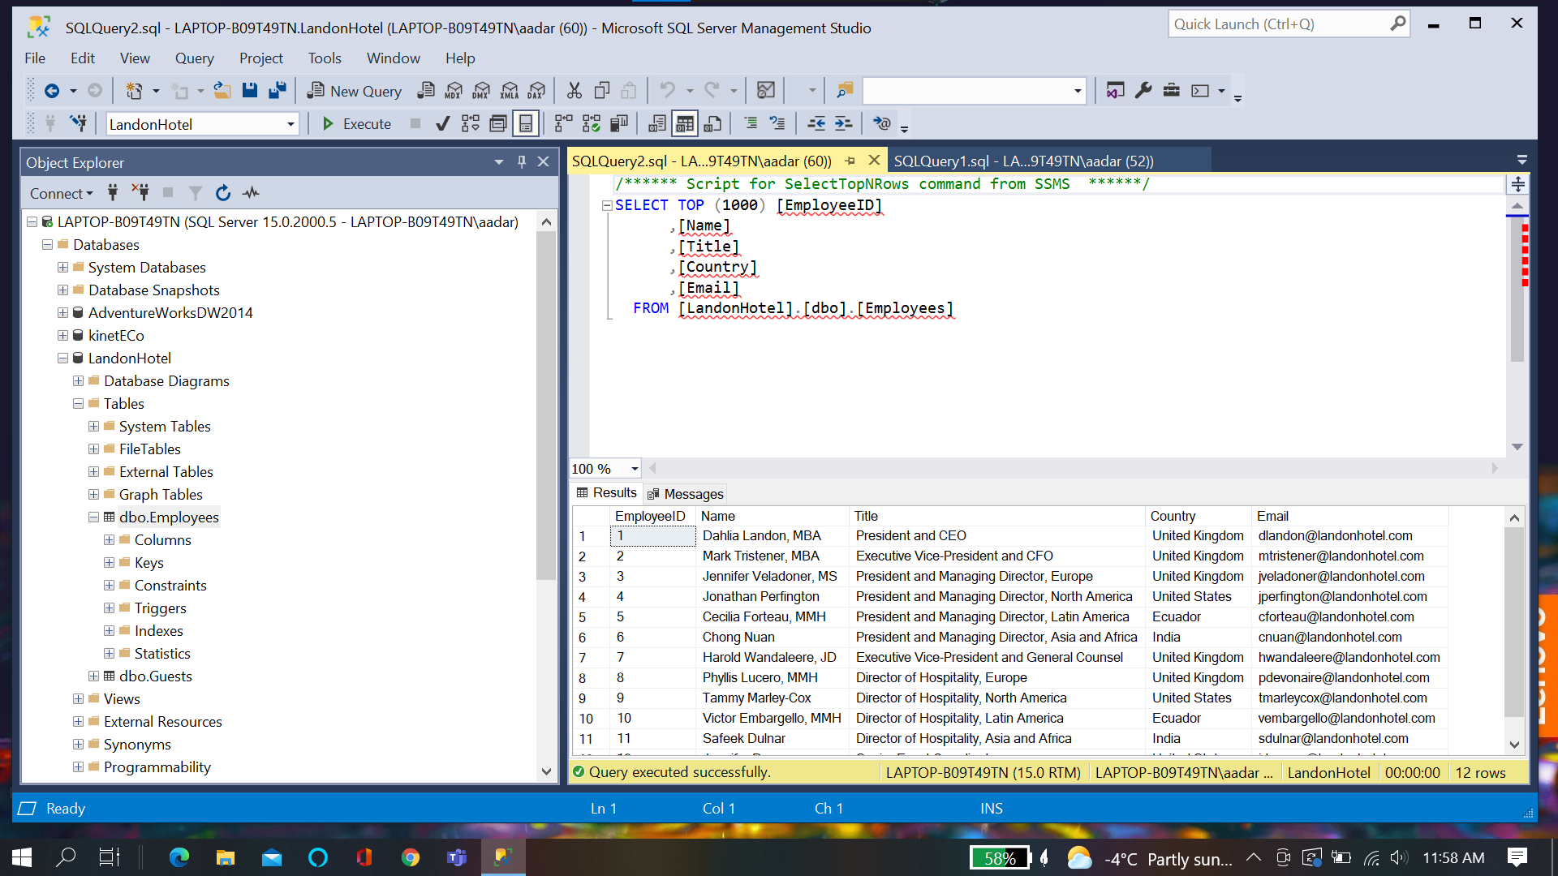

**Chapter quiz:**

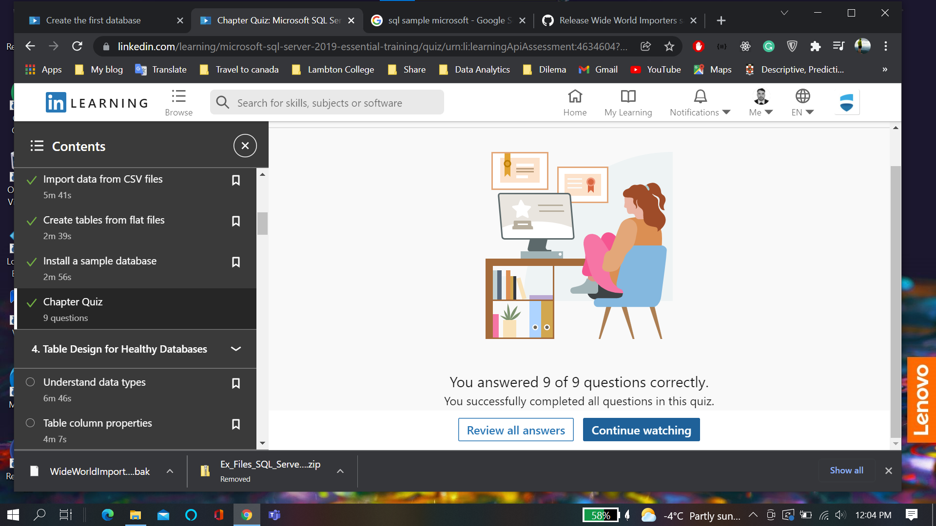

**Chapter 4:**

**Primary Key and default value**

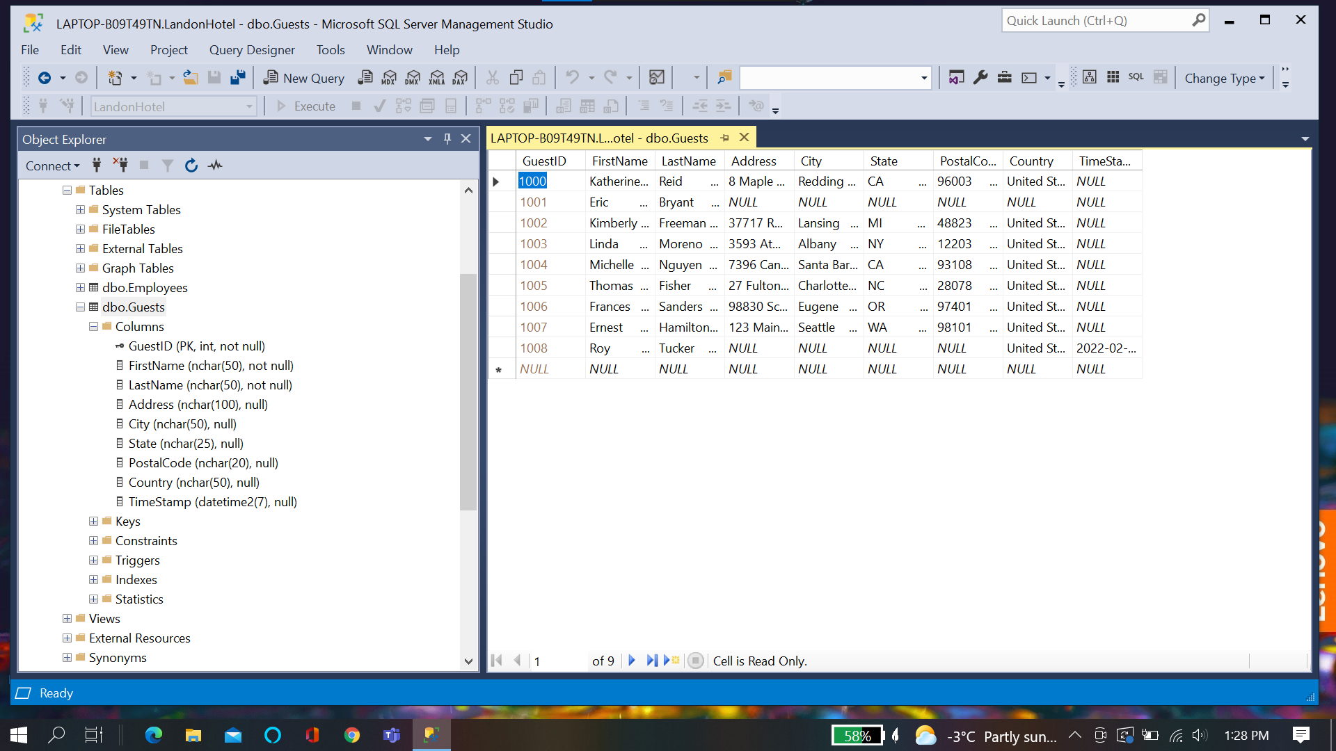

**Unique Constraints through index**

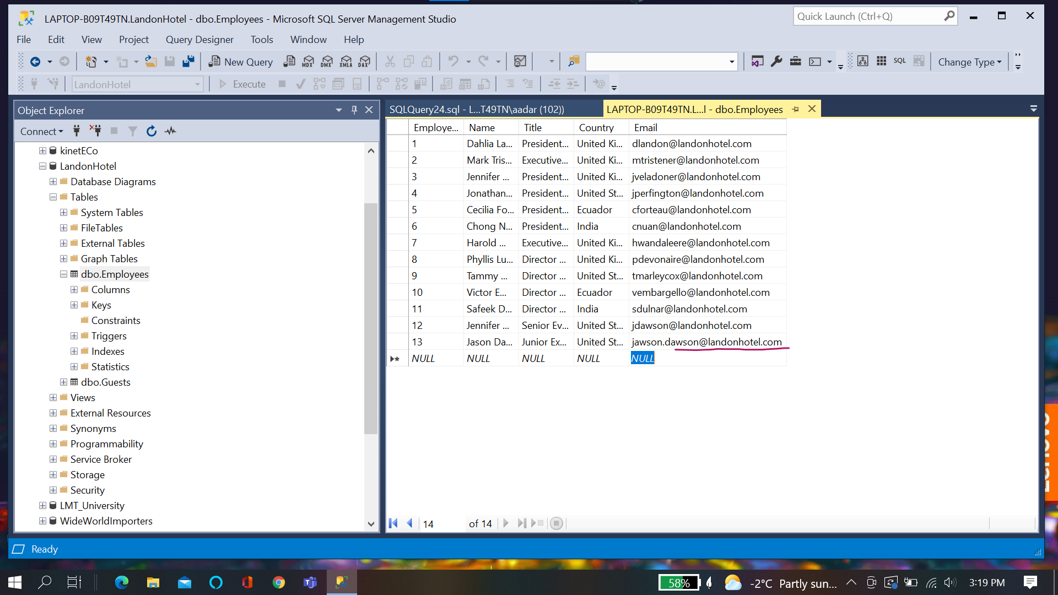

**Relationship between Tables:**

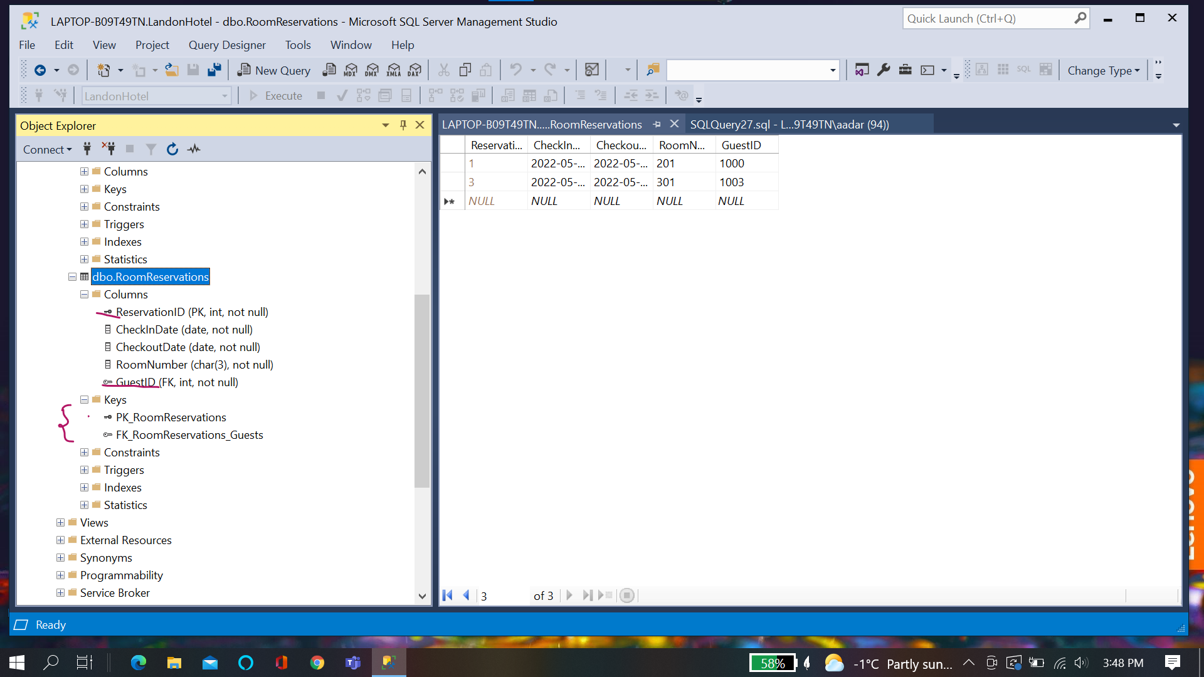

**Chapter Quiz:**

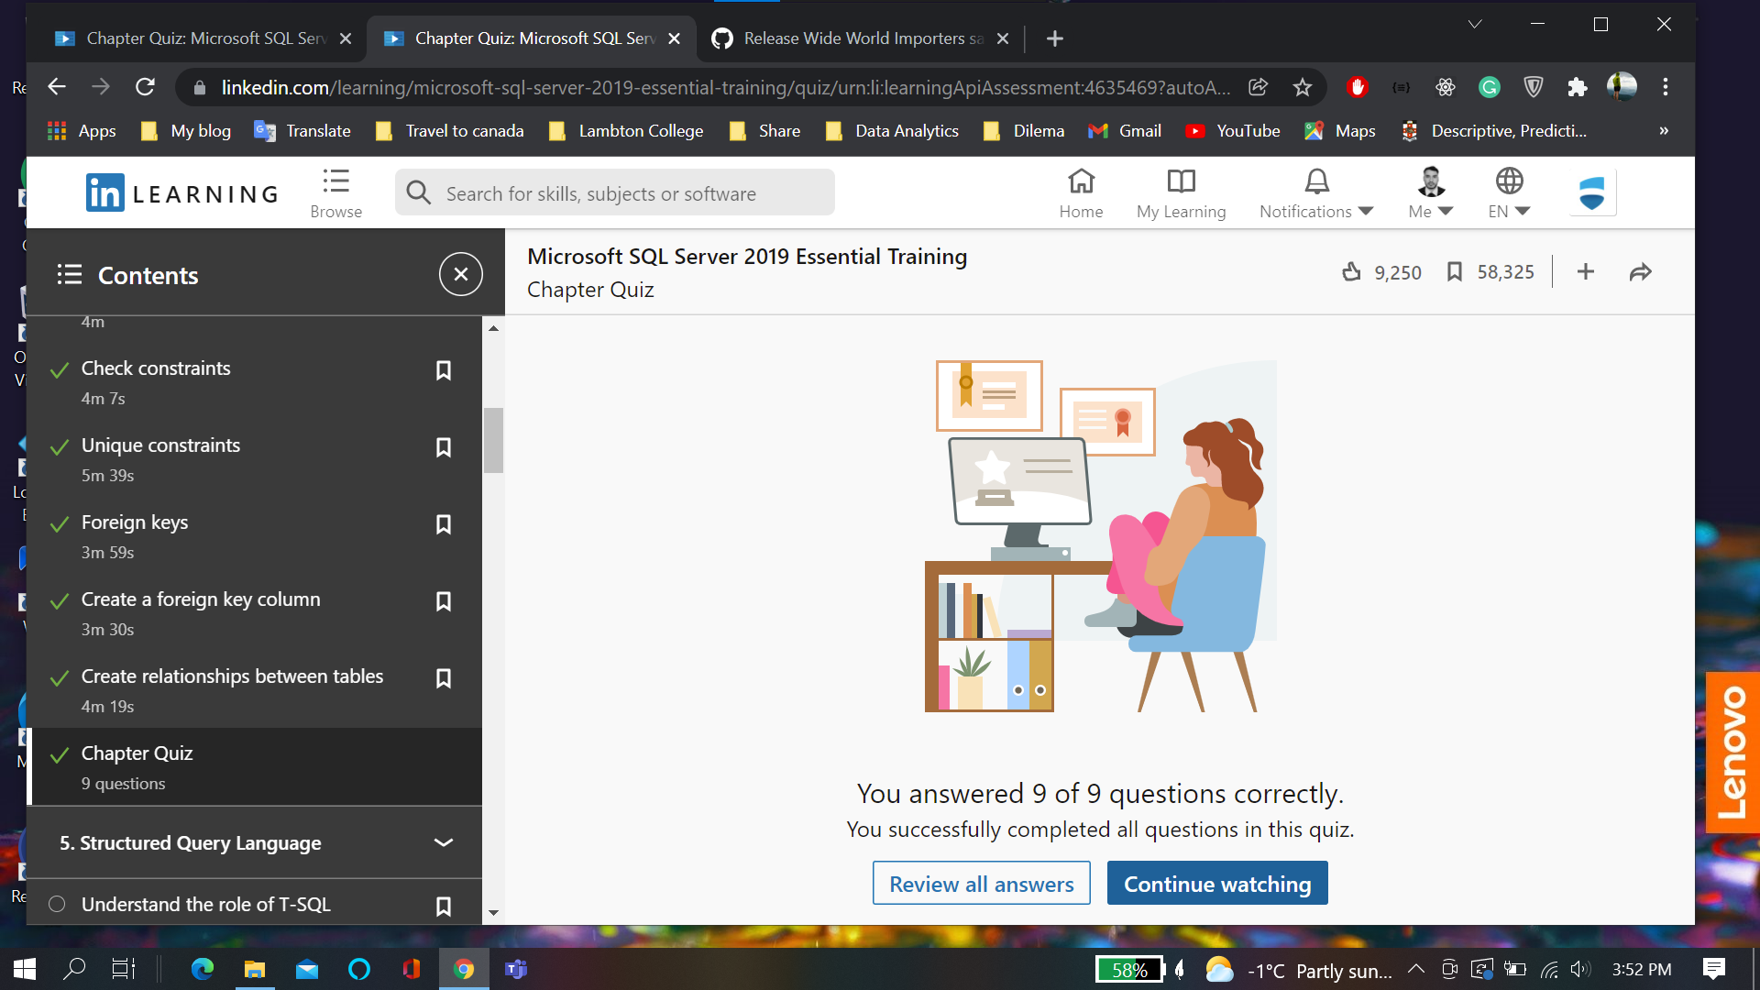

**Chapter 5:**

**Create Table**

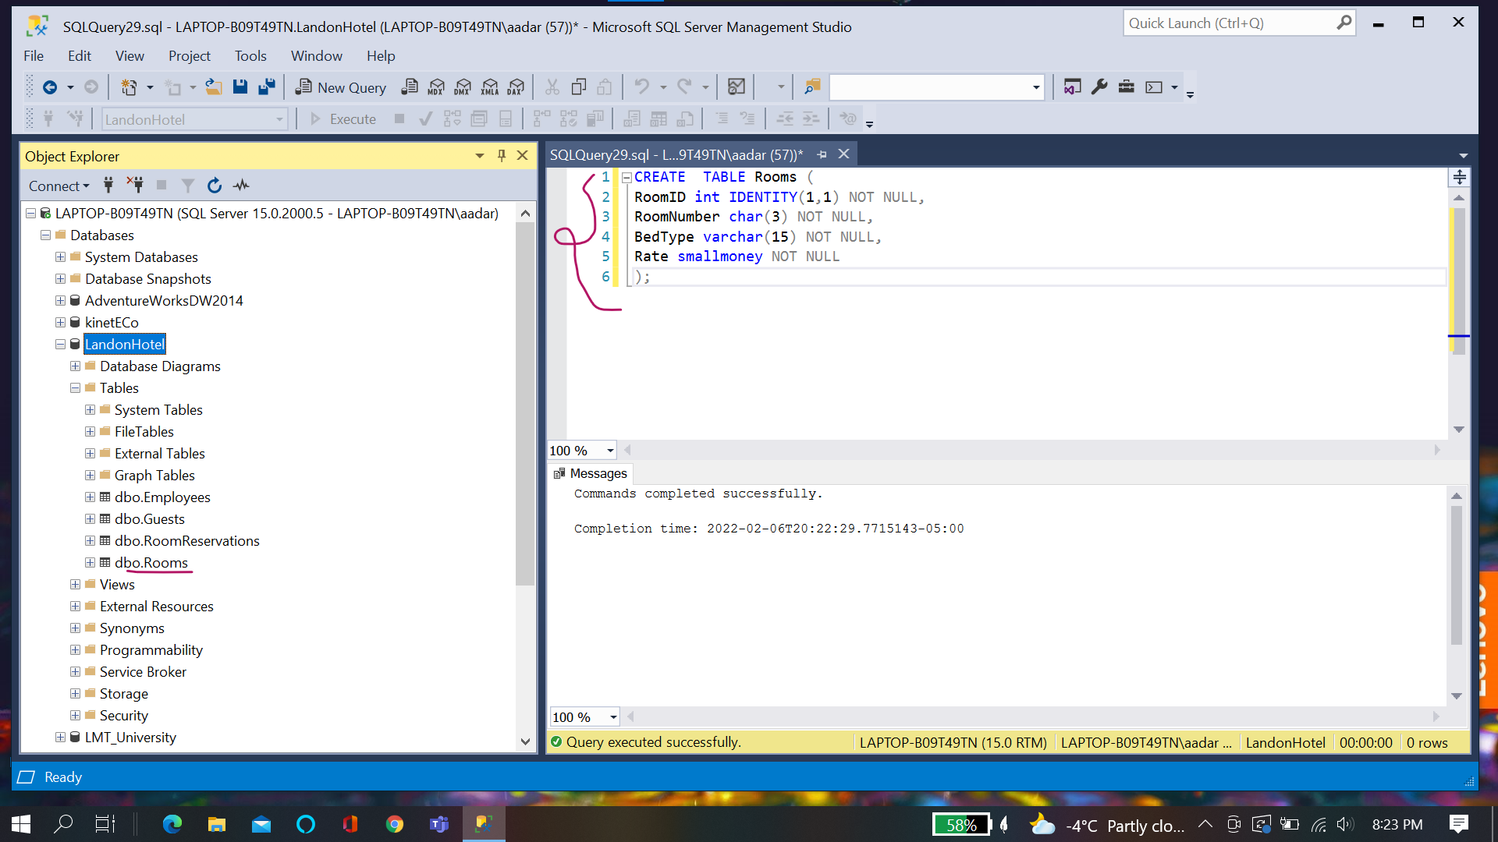

**Sort Data**

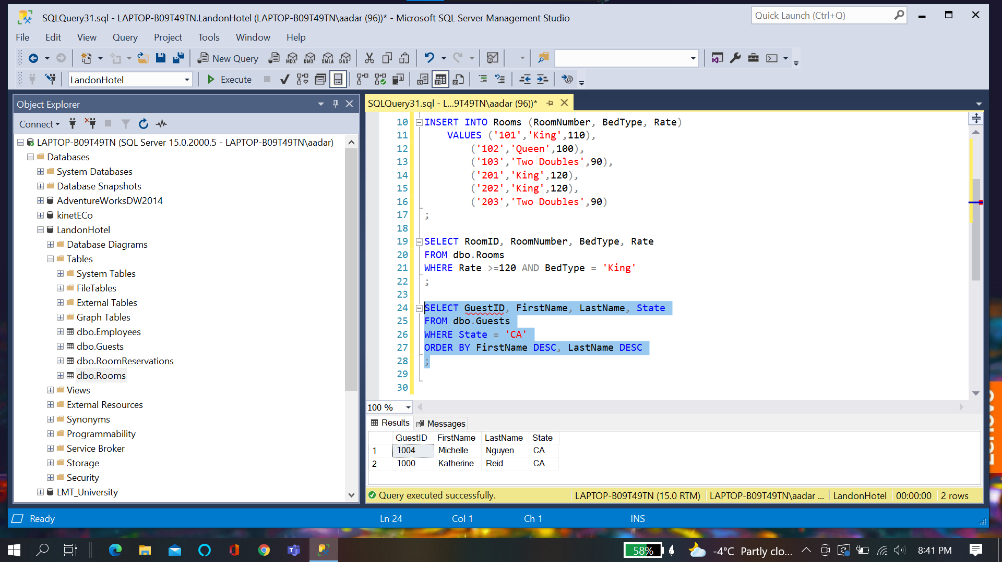

**Join**

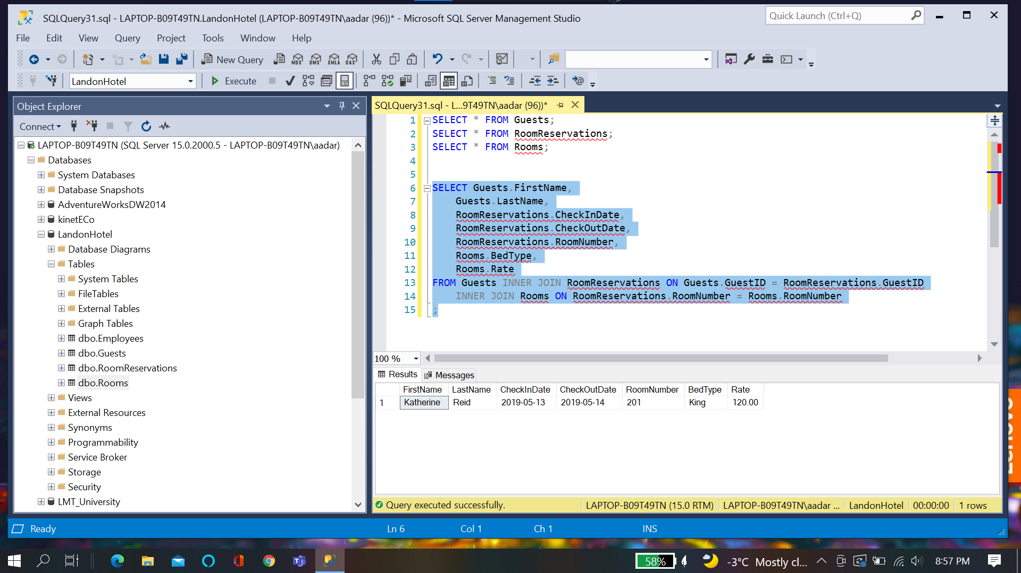

**Chapter Quiz:**

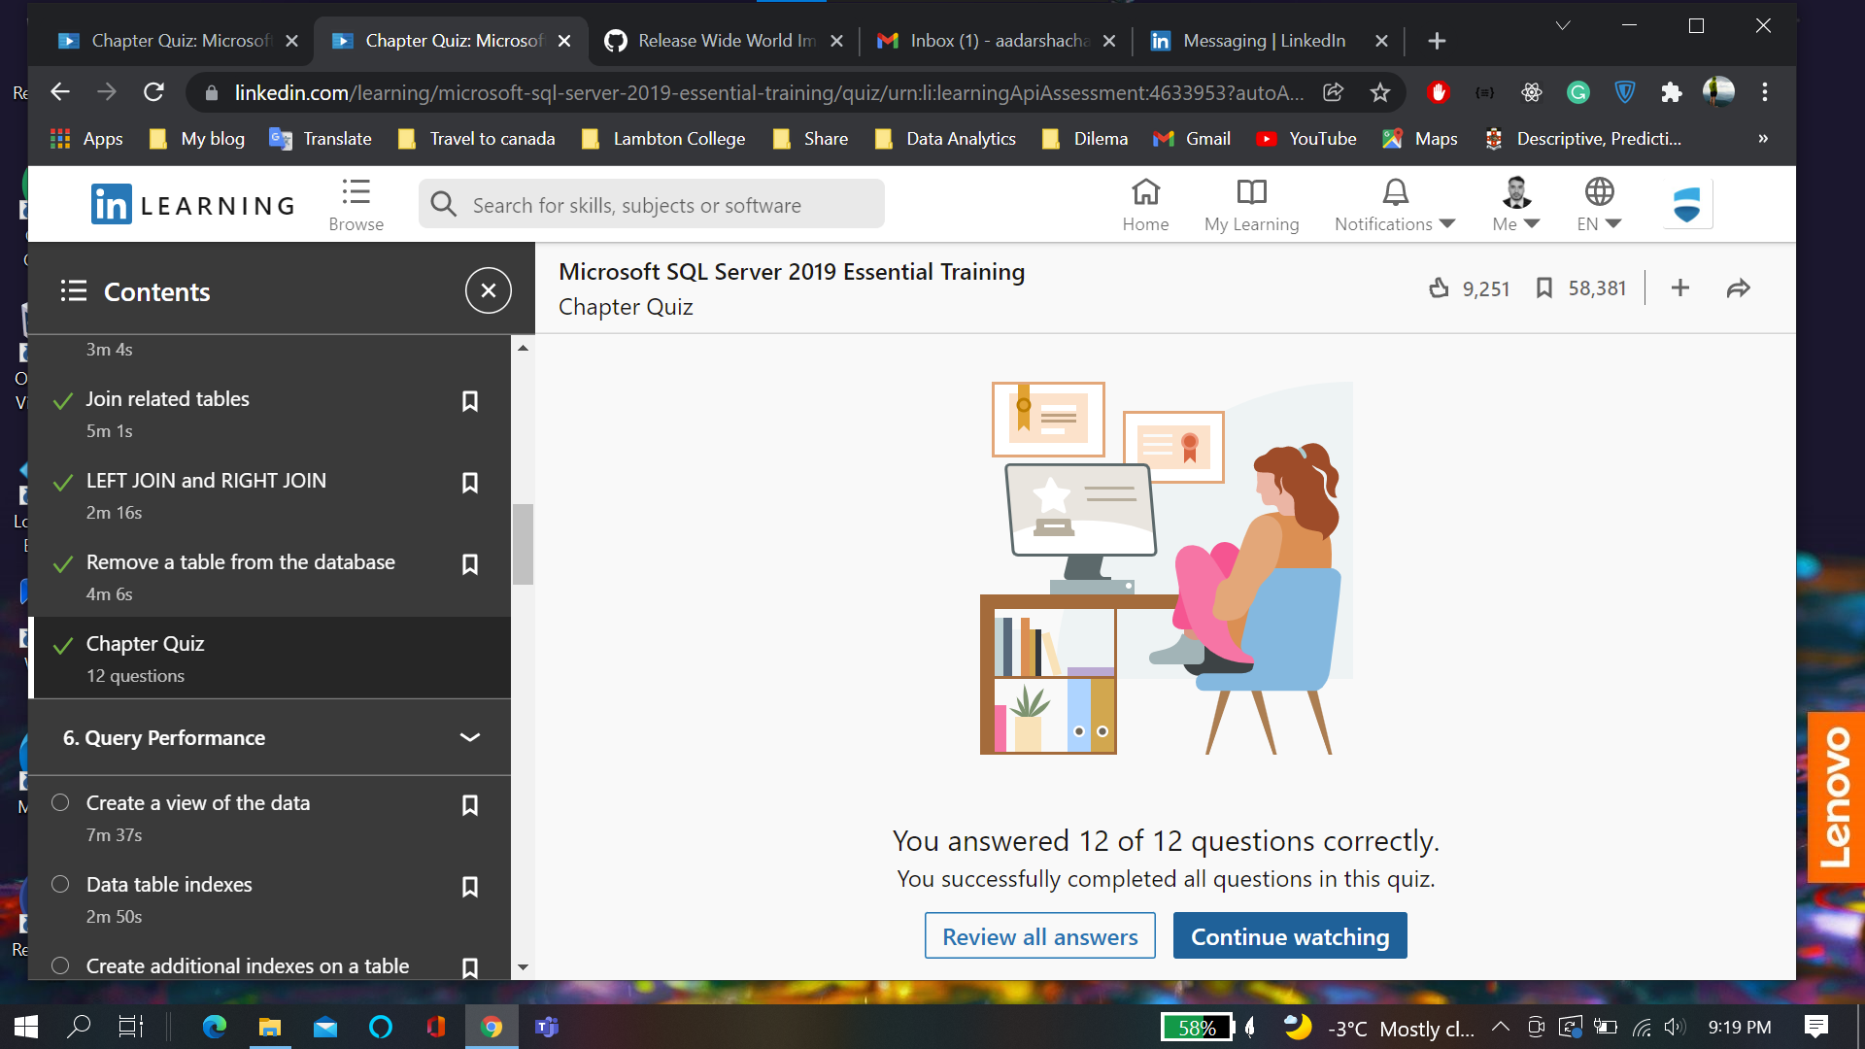

**Chapter 6:**

**Views:**

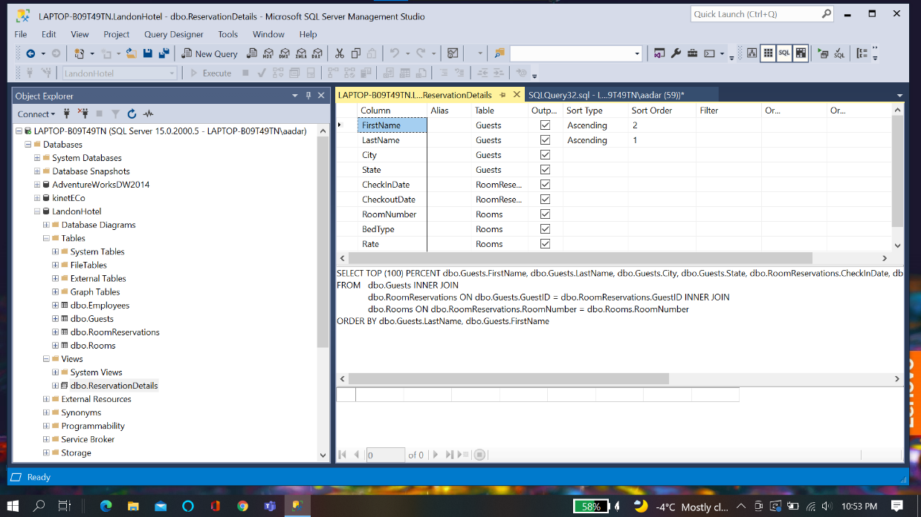

**Execution Plan:**

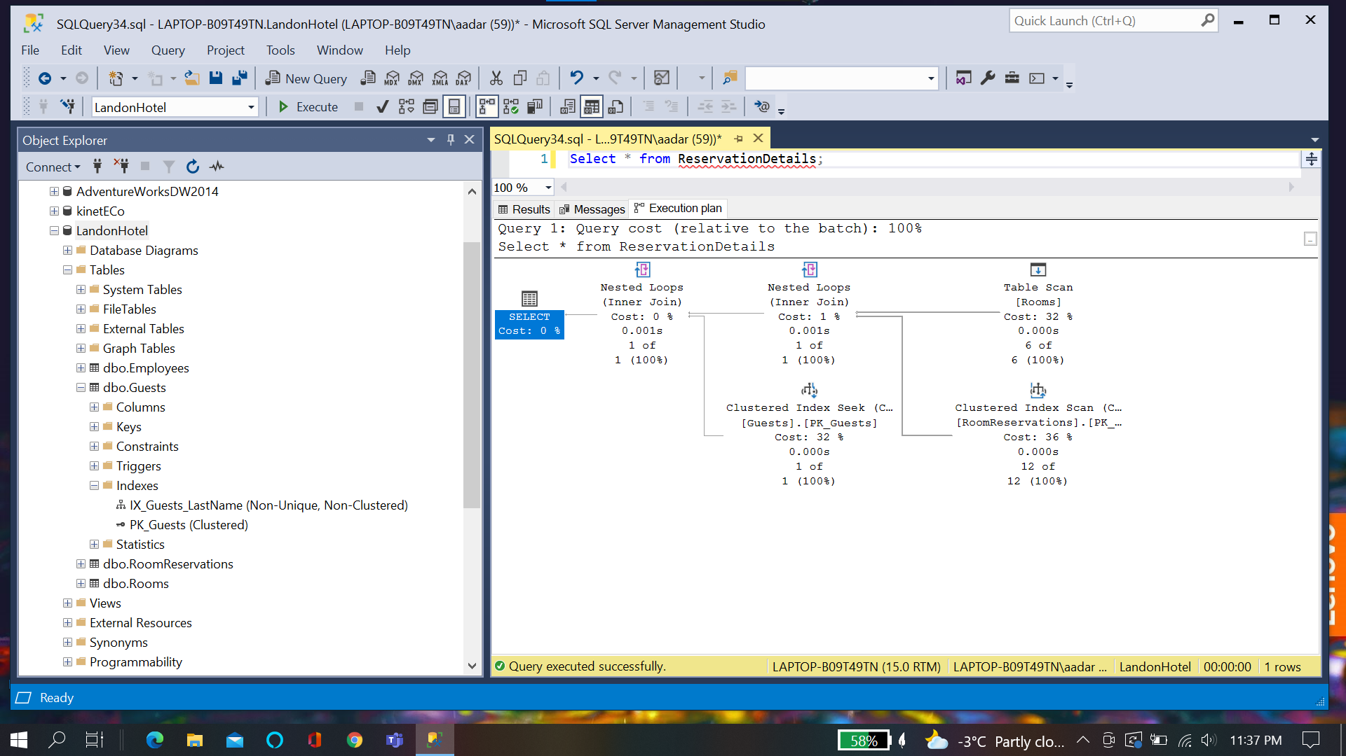

**Chapter quiz:**

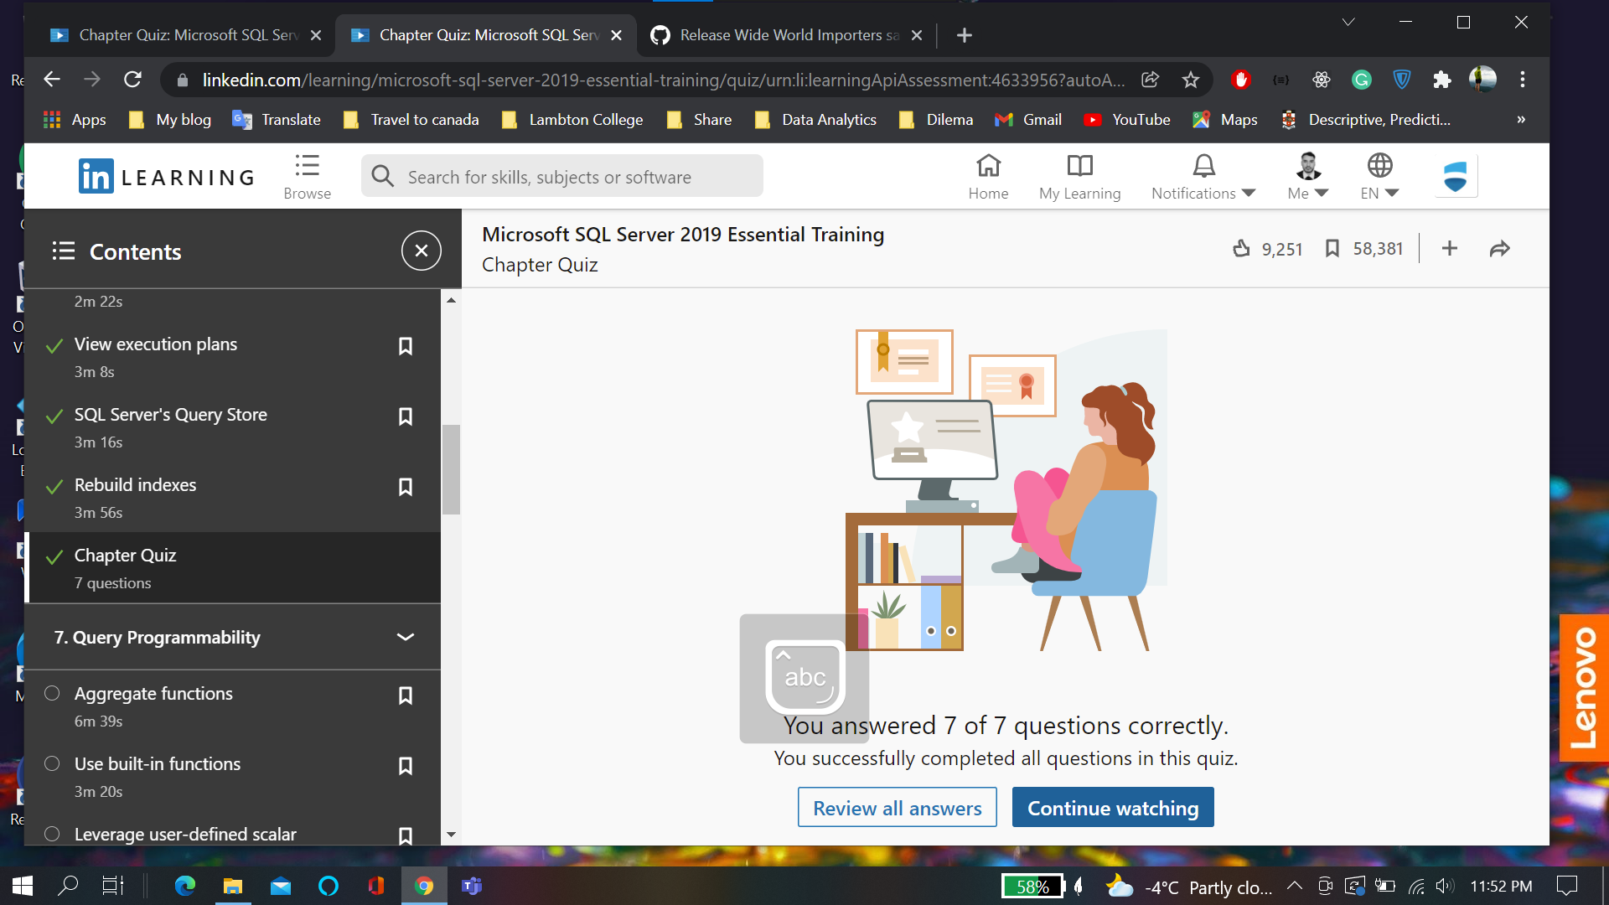

**Chapter 7:**

**Aggregates:**

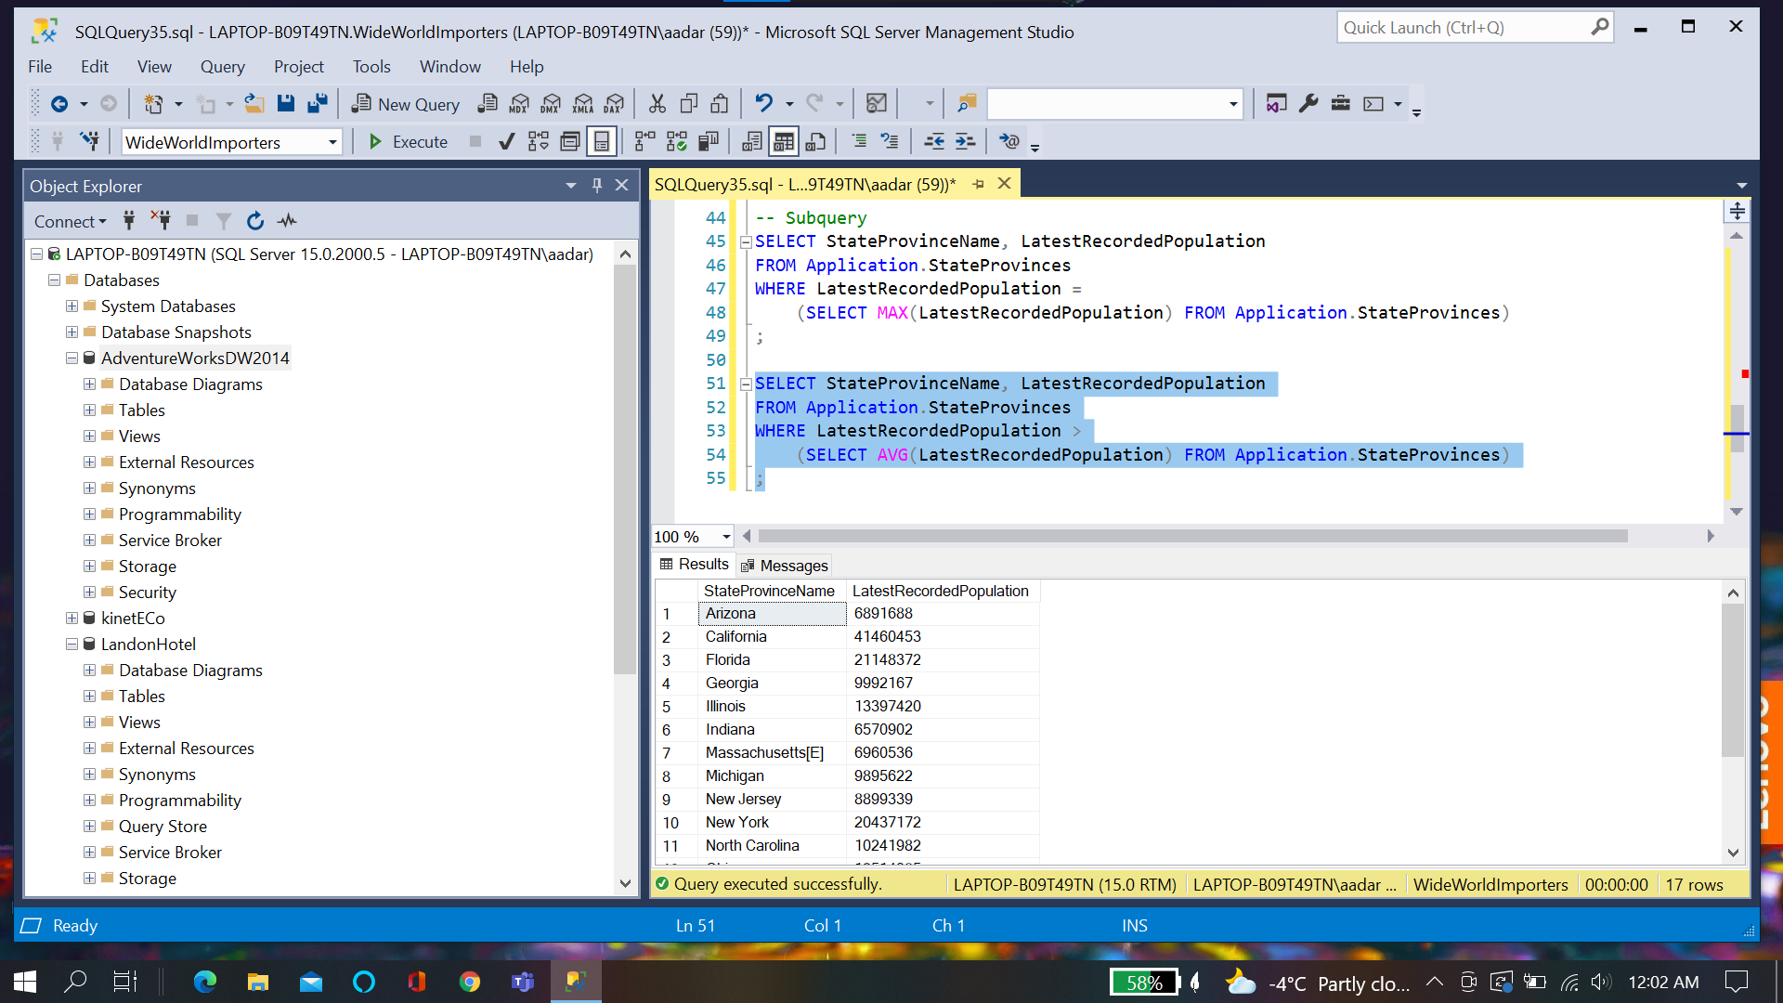

**Function**

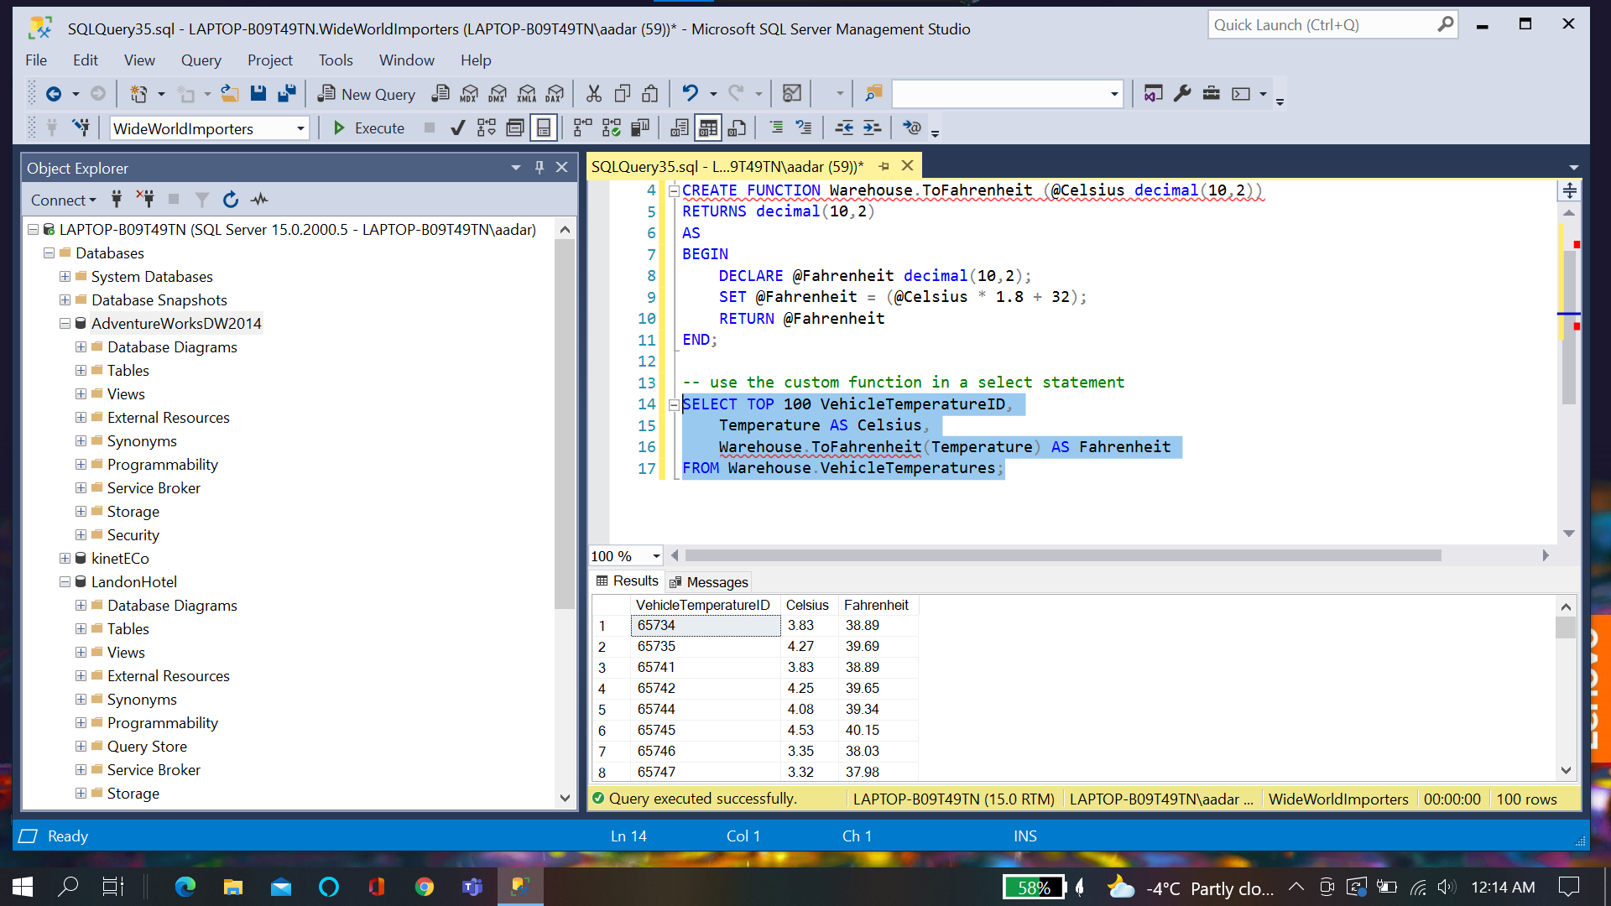

**Stored Procedure:**

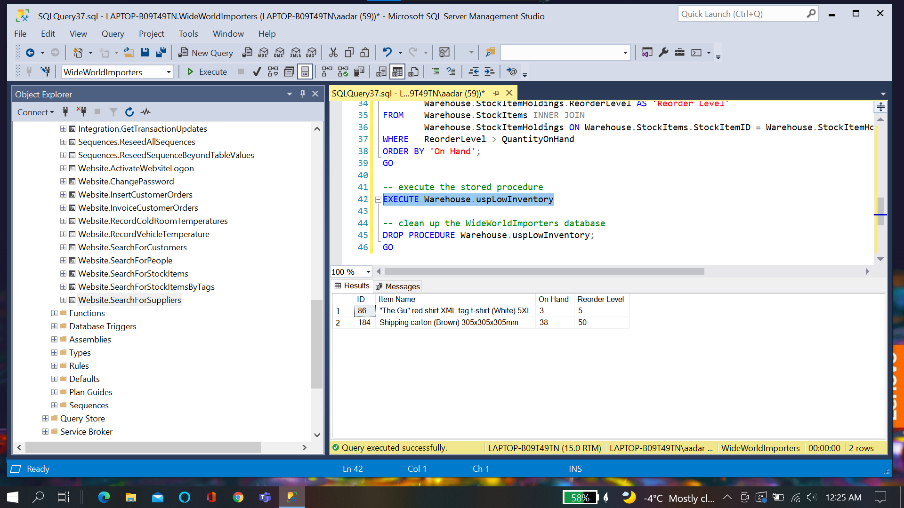

**Parameterized Procedure:**

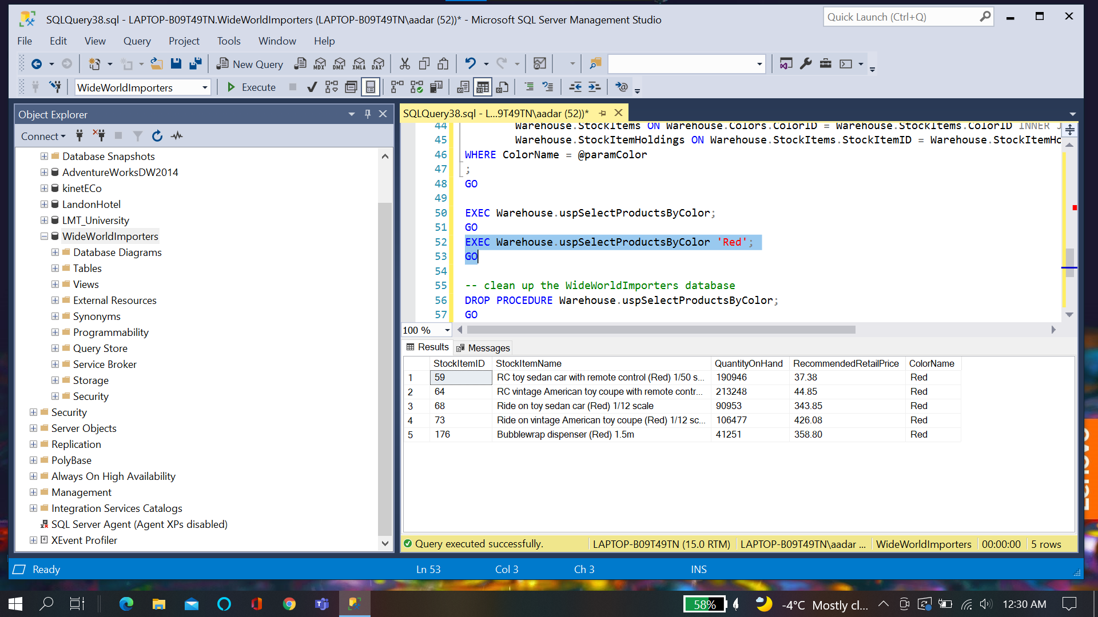

**Chapter Quiz:**

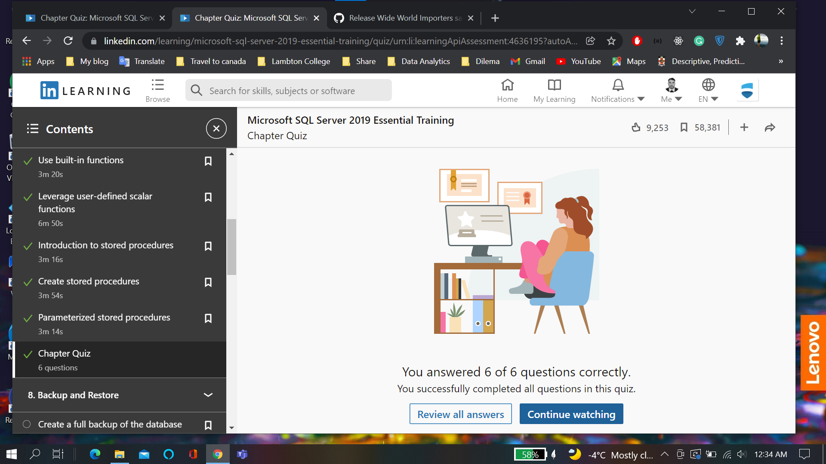

**Chapter 8:**

**Backup Differential**

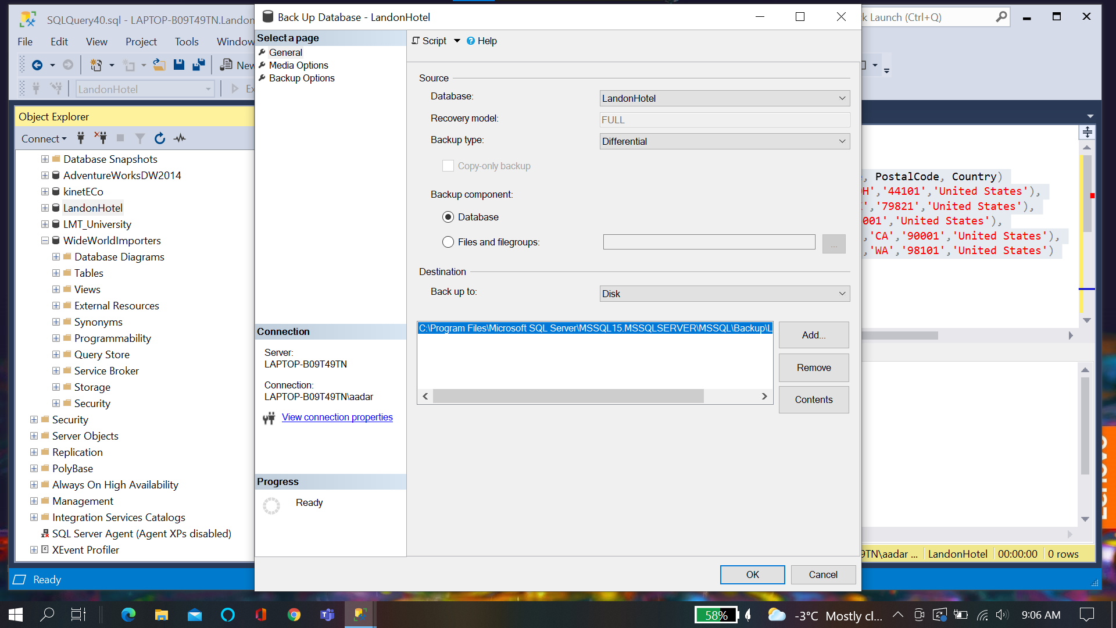

**Automate Backup:**

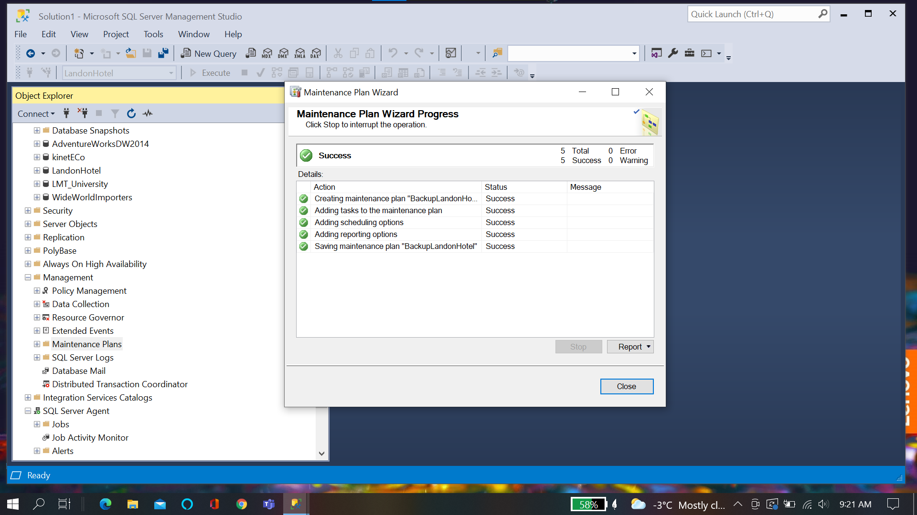

**Chapter Quiz**

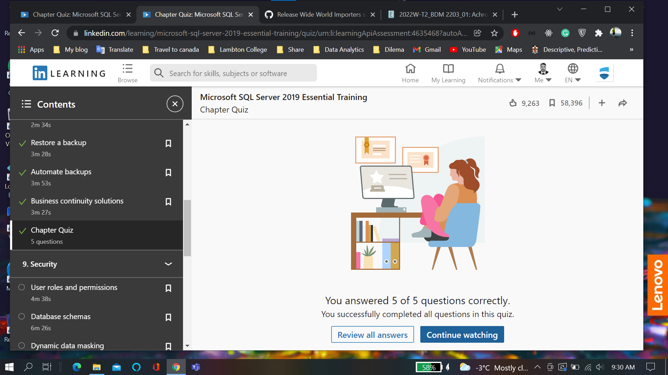

**Chapter 9:**

**Altering Schema to give permission**

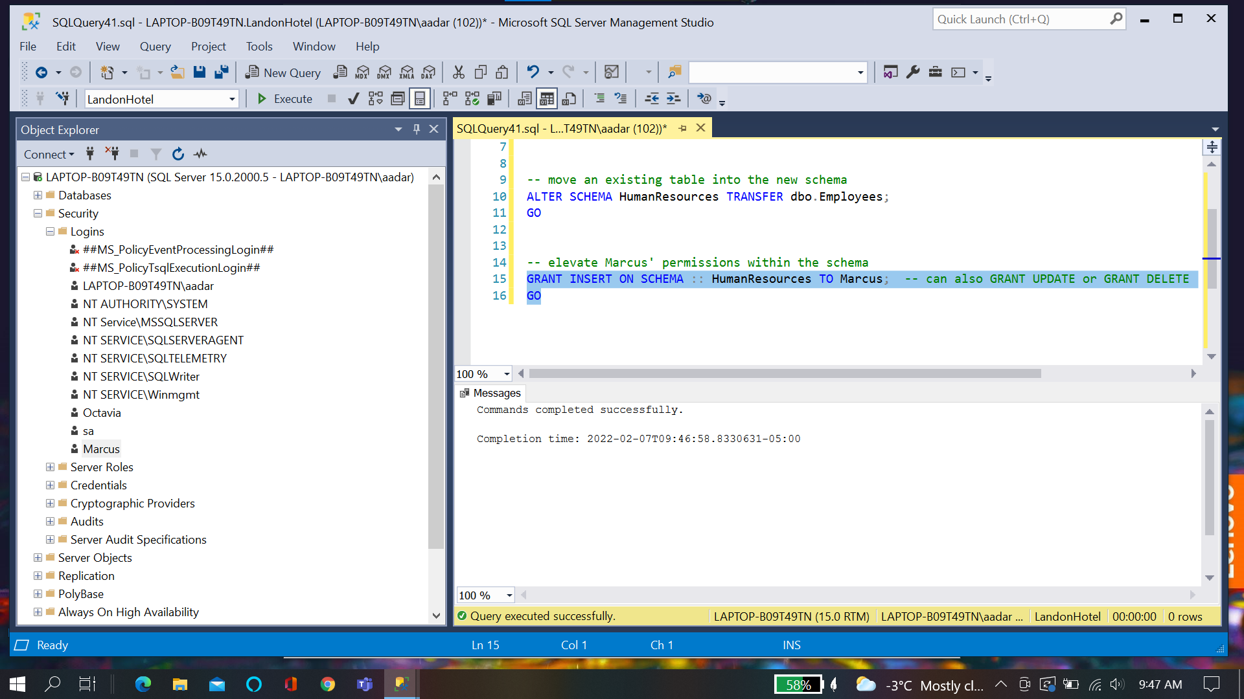

**Dynamic Data Masking:**

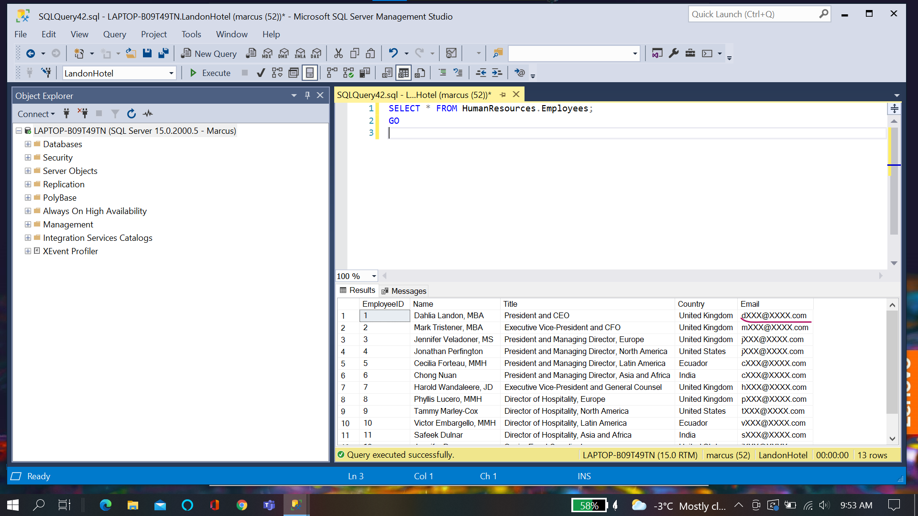

**Chapter Quiz:**

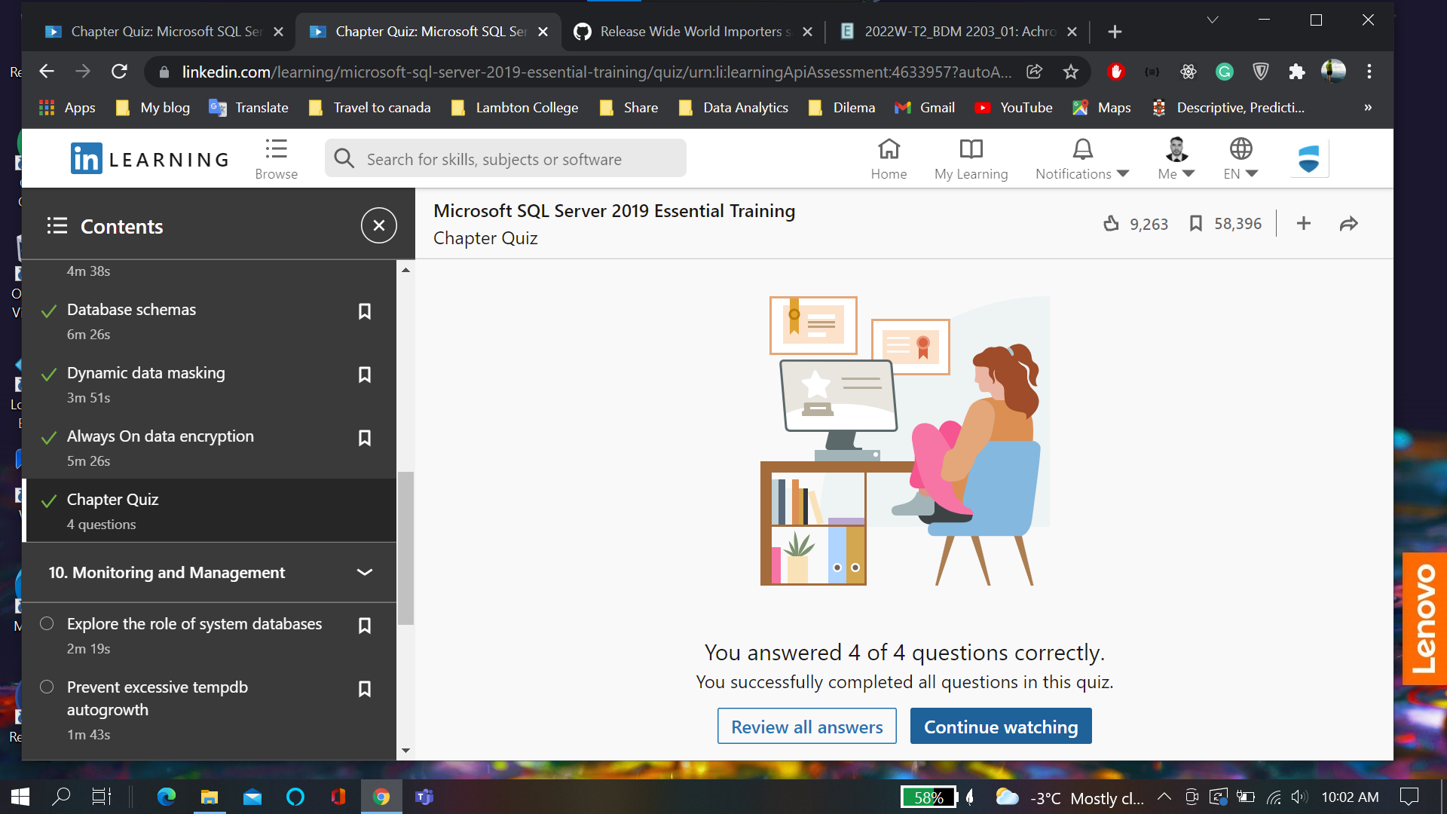

**Chapter 10**

**Error logs**

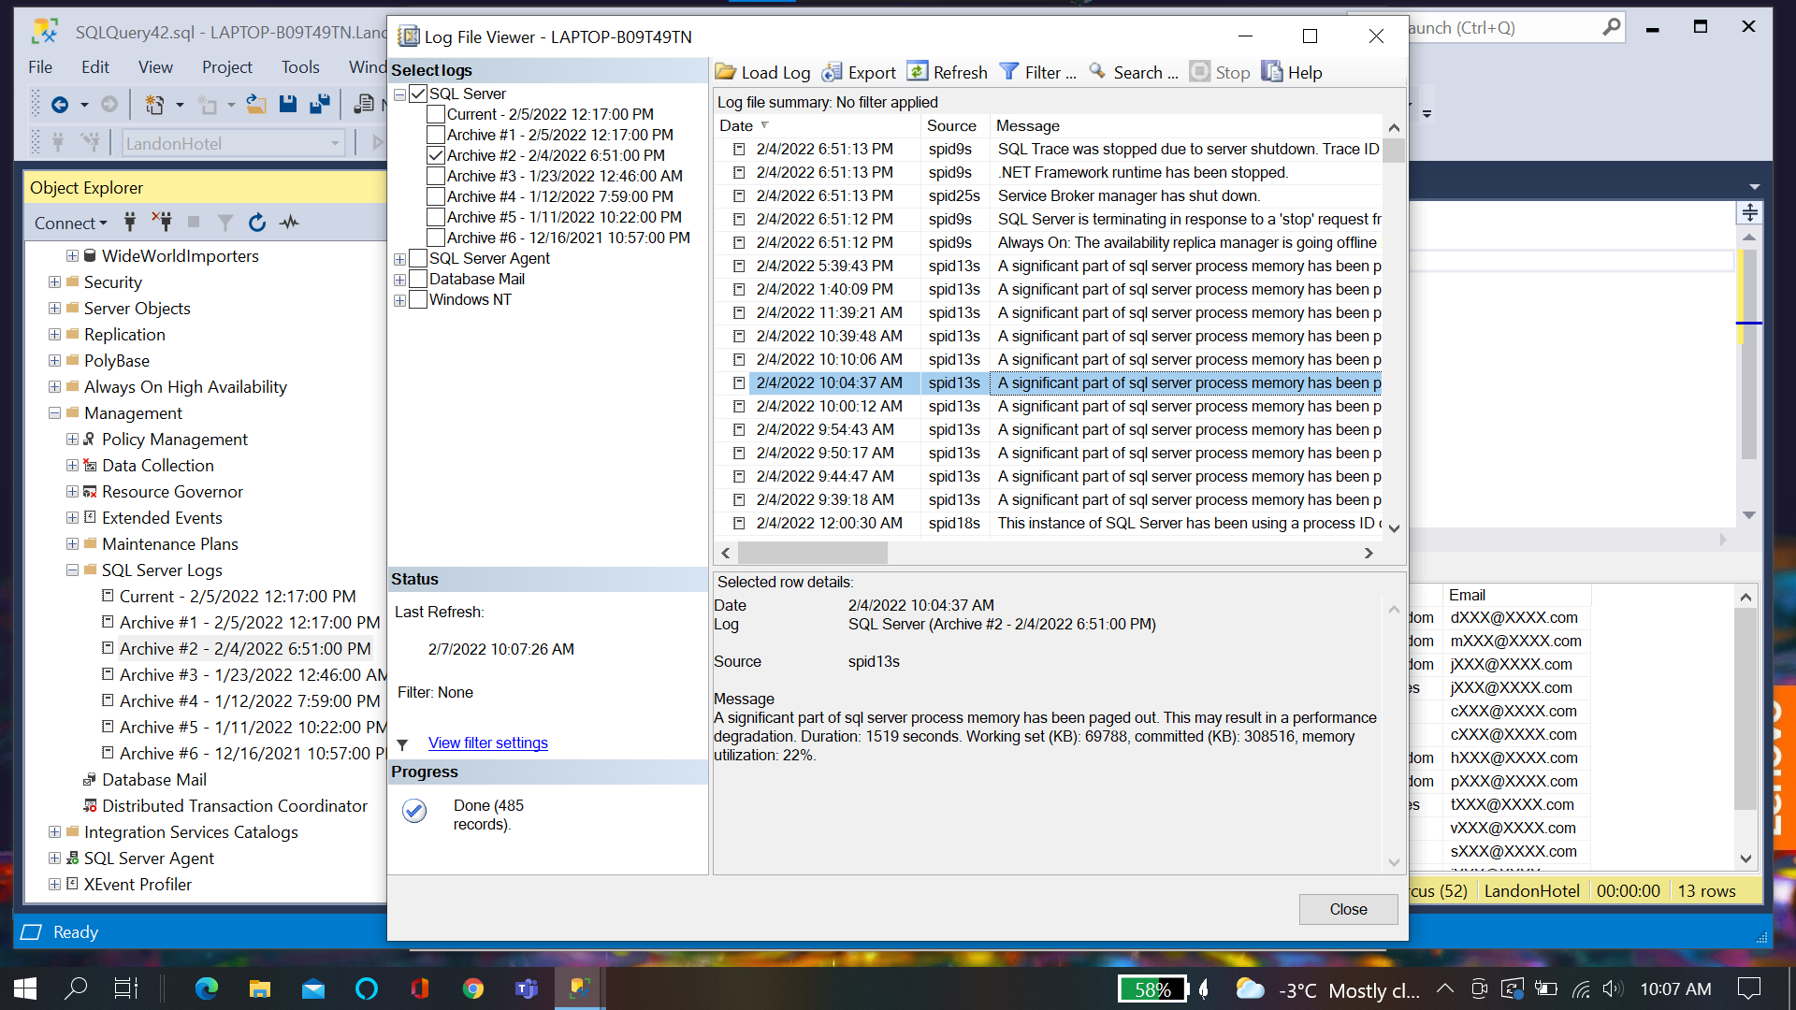

**Dynamic Management View:**

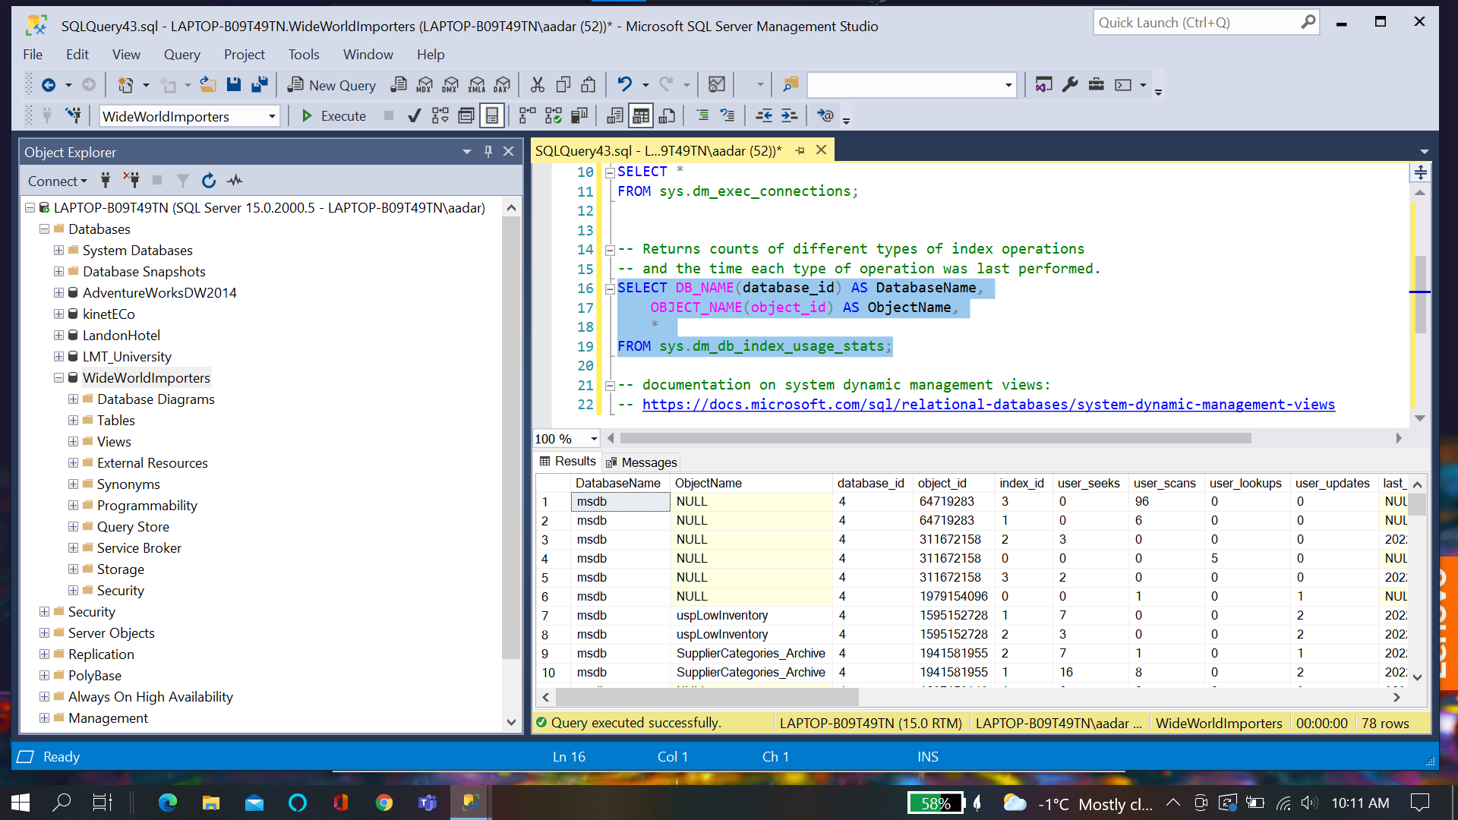

**Chapter Quiz:**

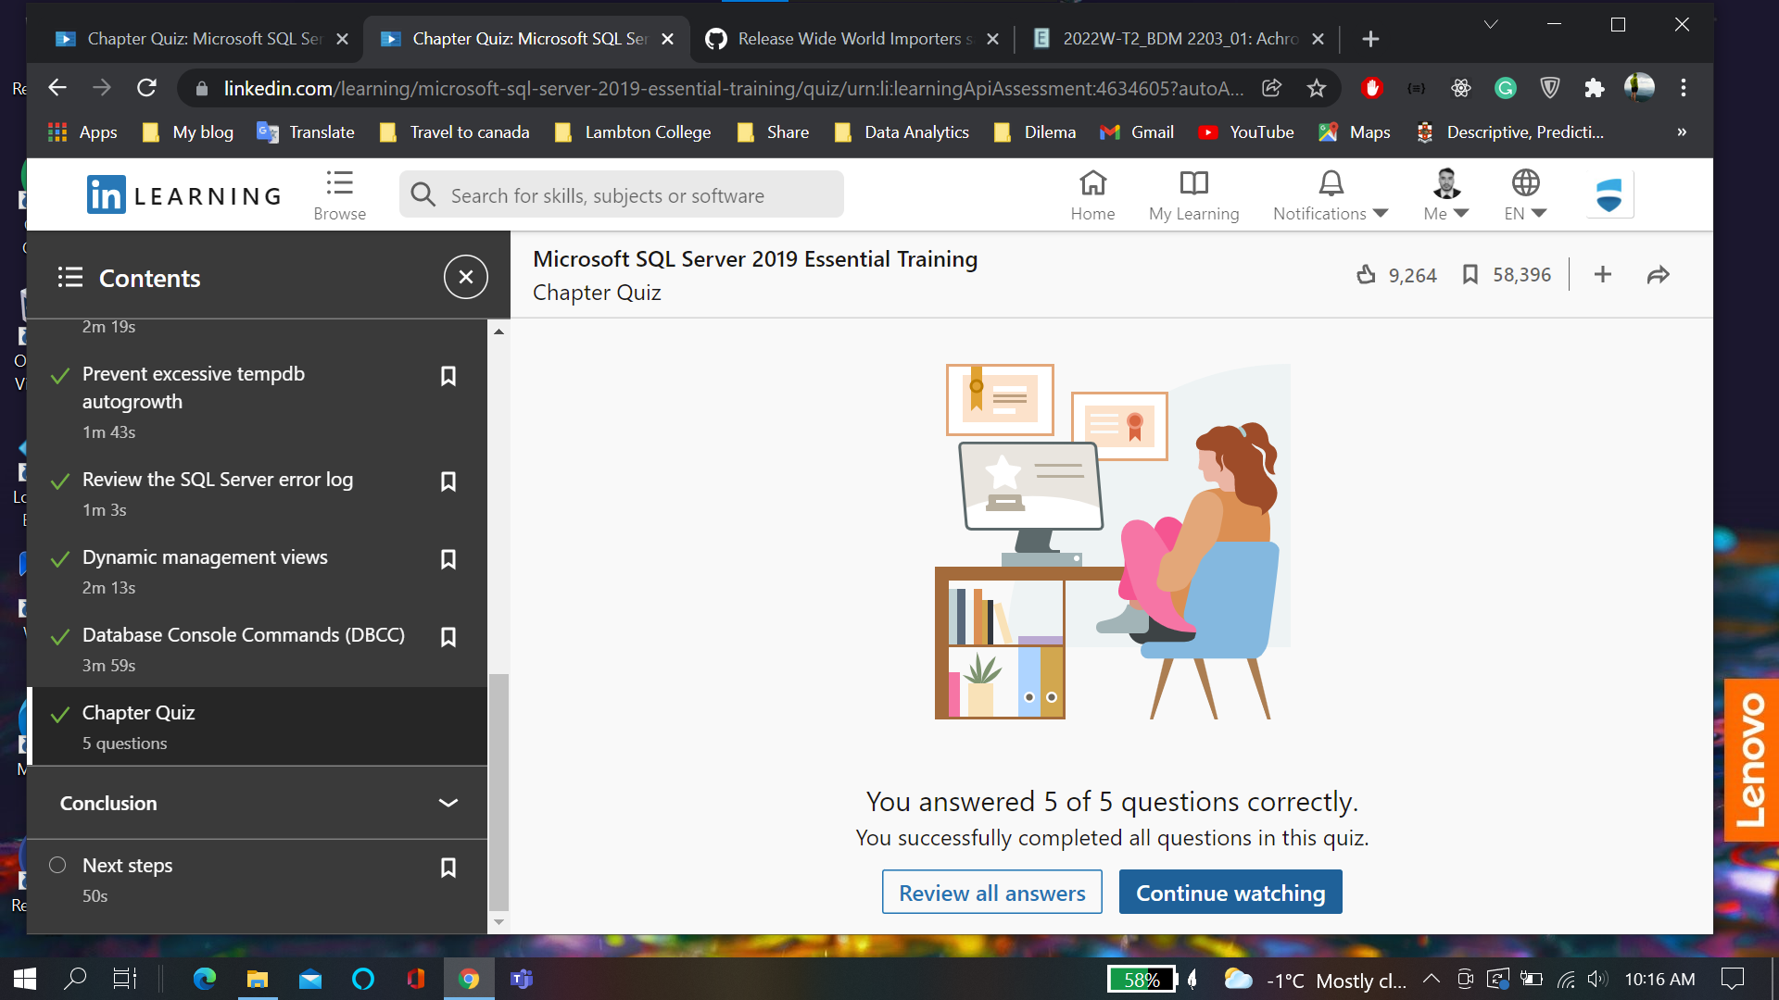

**Course Completion Certificate:**

